**Project Design Phase-II**

**Solution Requirements (Functional & Non-functional)**

|  |  |
| --- | --- |
| Date | 6 March 2025 |
| Team ID | SWTID1741257108149874 |
| Project Name | FitFlex |
| Maximum Marks | 4 Marks |

**Functional Requirements:**

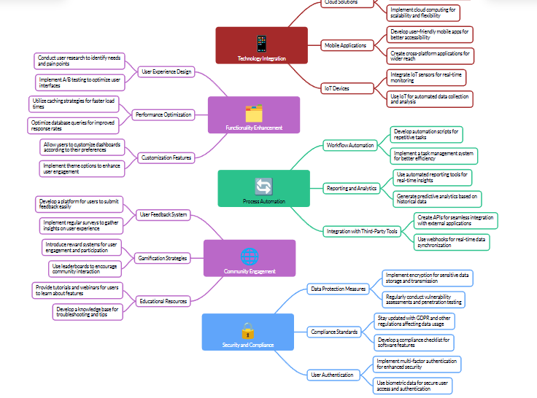

User Management

1. User Registration: Allow users to create accounts with username, email, and password.

2. User Login: Enable users to log in to their accounts using their credentials.

3. User Profile Management: Allow users to view and edit their profile information.

Workout Management

1. Workout Scheduling: Enable users to schedule workouts for specific dates and times.

2. Workout Tracking: Allow users to log and track their workouts, including exercises, sets, reps, and weight.

3. Workout Planning: Provide users with pre-built workout plans or allow them to create custom plans.

Exercise Management

1. Exercise Library: Maintain a library of exercises with descriptions, images, and videos.

2. Exercise Search: Allow users to search for exercises by name, muscle group, or equipment.

3. Exercise Creation: Enable users to create and add custom exercises to the library.

**NON FUNCTION REQURIMENT:**

